Village of Palmyra

Brush Collection and Chipping

Wood chip delivery is available to Residents on a first come, first serve basis.

Chips are delivered approximately 5 cubic yards at a time.

To be placed on the list, please call the DPW: (262) 495-4106
Brush Collection and Chipping takes place the 2nd Monday of each month April – November.
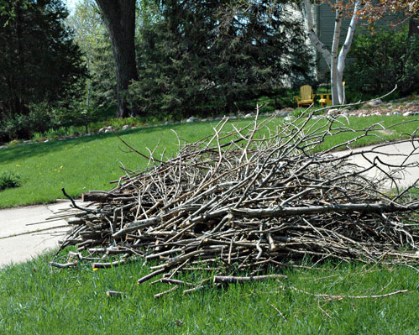
Resident Guidelines for Brush Collection

- Piles must be neatly stacked with the CUT ENDS FACING THE ROAD.
- Branches should not be larger than 4” in diameter and cut to a length not longer than 8’
- Branches should not be bagged, bundled or bound together.
- Please do not mix grass, leaves or other yard debris in with branches for collection. These items can be disposed of at the Yard Waste Site.
- Treated lumber, railroad ties and other landscaping lumber will not be collected.

For the courtesy of your neighbors and other Village Residents, please DO NOT place piles at the street more than 72 hours before scheduled pickup. Please see the schedule below for 2018 pickup dates.

**BRUSH WILL NOT BE PICKED UP IF GUIDELINES ARE NOT FOLLOWED**

Expectations of Chipping Services

This service is provided for general yard maintenance completed by the Residents themselves and is not meant for lot clearing, major, complete, or contracted tree removal.

- Chipping will be provided by the DPW for 20 MINUTES.
- Residents should notify the DPW if they have large piles for pickup. Residents will be billed for time periods over and above 20 minutes to complete pickup. Please remember, the neater that piles are stacked - the faster crews will be able to work and will be able to chip larger piles more efficiently.
********Exceptions to the above will be after any major storm damage. ********
- Should there be large amounts of brush, pickup services may not be completed by the DPW in a one day period, but will be finished in the days to follow.

- This brush pickup is in addition to the Village’s Yard Waste Site) and is meant to allow for providing beneficial services to all Village Residents.

Revised 1/2016
Yard Waste Site Open Village of Palmyra - 2020 Brush Collection
Y.W. Open - Weather Dependent Brush Chipping & Yard Waste Site Schedule Electronic Waste Site

January  S M T W Th F S  1 2 3 4  5 6 7 8 9 10 11  12 13 14 15 16 17 18  19 20 21 22 23 24 25  26 27 28 29 30 31 | February  S M T W Th F S  1  2 3 4 5 6 7 8  9 10 11 12 13 14 15  16 17 18 19 20 21 22  23 24 25 26 27 28 29 | March  S M T W Th F S  1 2 3 4 5 6 7  8 9 10 11 12 13 14  15 16 17 18 19 20 21  22 23 24 25 26 27 28  29 30 31 | April  S M T W Th F S  1 2 3 4  5 6 7 8 9 10 11  12 13 14 15 16 17 18  19 20 21 22 23 24 25  26 27 28 29 30
May  S M T W Th F S  1 2  3 4 5 6 7 8 9  10 11 12 13 14 15 16  17 18 19 20 21 22 23  24 25 26 27 28 29 30  31 | June  S M T W Th F S  1 2 3 4 5 6  7 8 9 10 11 12 13  14 15 16 17 18 19 20  21 22 23 24 25 26 27  28 29 30 | July  S M T W Th F S  1 2 3 4  5 6 7 8 9 10 11  12 13 14 15 16 17 18  19 20 21 22 23 24 25  26 27 28 29 30 31 | August  S M T W Th F S  1  2 3 4 5 6 7 8  9 10 11 12 13 14 15  16 17 18 19 20 21 22  23 24 25 26 27 28 29  30 31
September  S M T W Th F S  1 2 3 4 5  6 7 8 9 10 11 12  13 14 15 16 17 18 19  20 21 22 23 24 25 26  27 28 29 30 | October  S M T W Th F S  1 2 3  4 5 6 7 8 9 10  11 12 13 14 15 16 17  18 19 20 21 22 23 24  25 26 27 28 29 30 31 | November  S M T W Th F S  1 2 3 4 5 6 7  8 9 10 11 12 13 14  15 16 17 18 19 20 21  22 23 24 25 26 27 28  29 30 | December  S M T W Th F S  1 2 3 4 5  6 7 8 9 10 11 12  13 14 15 16 17 18 19  20 21 22 23 24 25 26  27 28 29 30 31

